

ENSF614: Advanced System Analysis

**Final Project Part A**

|  |  |
| --- | --- |
| Course instructor: | Dr Moussavi |
| TA | Anja & Yobbasim |
| Date of submission: | 28th November 2021 |
| By | Michael Ah-Kiow (30019892)  Amir Abbaspour (30076398)  Brandon Attai (30146080)  Kayode Awe (30139223) |

Table of Contents

1 Use Case Diagram (Michael) 1

2 Systems Activity diagram (Michael) 2

3 State Transition Diagram (Michael) 3

3.1 Ticket State Diagram (Michael) 3

3.2 Payment Object State Diagram (Michael) 3

4 Scenarios and CandiDate Objects (Brandon & Kayode) 5

4.1 List of Candidate classes (Michael) 10

4.2 Selected Classes from Candidate 10

4.2.1 Models: 10

4.2.2 Boundary classes: 10

4.2.3 Controllers 10

4.2.4 User Interface 10

4.2.5 Design Patterns 10

5 System Interaction Diagram: 11

5.1 Login (Michael) 11

5.2 Search a movie (Kayode) 12

5.3 Buy a Movie Ticket (Amir) 12

5.4 Refunding a Movie Ticket (Brandon) 13

6 DESIGN LEVEL CLASS SPECIFICATION (Amir) 14

6.1 Relationships (group) 14

6.2 Attributes & Methods (Amir) 15

7 Package Diagram (Amir) 18

8 Deployment Diagram (Brandon) 19

9 Appendix A: Wireframes and UI Examples (Michael) 20

9.1 Login/Continue as Guest 20

9.2 News (Window that pops up whenever you login) – Receive news. 21

9.3 Main menu 21

9.4 Movie Search, Theater and Seat Selection & Buy ticket 22

9.5 Ticket Info (When you press pay, and payment is confirmed by External actor) 23

9.6 Refund (Enter details and press refund) 24

# Use Case Diagram (Michael)

The use case diagram is composed of actors and use cases to show the sequence of actions that the system will perform to operate the theater ticketing App. Note that for simplicity and scope of the project, the engineering team has decided to treat the Billing, admin and payment systems as external actors and thus not part of our system.

# Systems Activity diagram (Michael)

This image shows the possible activity diagram of the whole system.

# State Transition Diagram (Michael)

The state transition diagram is a diagram showing how an object view or state can change depending on operations in the system. The group has developed 2 state transition diagrams:

1. A Ticket Object State diagram
2. A Payment Object state diagram (Broken into two, to show both refunds and payment).

## Ticket State Diagram (Michael)

The State diagram of the ticket is pretty simple. A ticket is created when the customer buys a ticket. The state then goes into active until the movie is shown or the user request a refund.

The ticket either change states into “refunded” or “consumed” and end state.

## Payment Object State Diagram (Michael)

There are 2 main options for the payment state diagram. Either a payment or a refund is initiated. Either way, the changes from its initial state to either accepted (payment) or verified (ticket is verified for refund) before it’s consumed or paid, and a receipt is sent to confirm the transaction. Refer to the figures below for more context. We are assuming that if payments, the billing system will take care of it (i.e. an external action) and thus there’s no error handling and this is the engineering decision of the team to avoid going down a rabbit hole).

# Scenarios and CandiDate Objects (Brandon & Kayode)

**Login (Brandon)**

A registered user enters their username and password into the system and the system validates the registered users’ username and password. If a correct username and password is entered, the information is validated against the information stored in the database and allows the user to view the menu. The user is then shown the menu to search for a movie.

|  |  |
| --- | --- |
| Name | Login |
| Description | On request from a registered user, allows for entry into the system with registered user authorization. |
| Precondition | Enters correct username and password |
| Post Condition | Registered user is shown the menu |
| Error Situation | Enters incorrect username and password |
| Primary Actors | Registered User |
| Secondary Actors | Database |
| Standard Process | 1) Registered user enters their username and password  2) Registered user is granted access to the menu with the required authorization |
| Alternative Process | 1) Enters the system as a guest user |

**Search Movie (Brandon)**

A user enters the menu. The system asks the user to select an option to search for a movie. The current movie repository that are being shown in the theaters are displayed to the user. The user can view all movies available. The user can optionally, search for a movie by name or genre. If a movie is searched for by name or genre, the database is queried for the movie and the system displays whether the movie is being shown and the details about the movie including a list of theatres and (locations) where the movies are being shown. The user can then select a movie.

|  |  |
| --- | --- |
| Name | Search Movie |
| Description | Searches for movies currently being shown |
| Precondition | User selects the search for movie option |
| Post Condition | User is shown a list of movies or selected movie |
| Error Situation | No movies are available |
| Primary Actors | Guest User, Registered User |
| Secondary Actors | Database |
| Standard Process | 1) User searches for a movie by viewing all  2) User is shown the query results – movie details and theatres being shown  3) User selects a movie |
| Alternative Process | 1) User searches for a movie by name – Standard process continues |

**View Showtimes (Brandon)**

The user selects a movie. The system accepts the input and queries the database for theatres available. The available theatre locations where the movie is being shown and displays it to the user. The user can select a theatre based on the name of the theatre to view the available show times. The system then accepts the input then queries the database for the showtimes available. The show times are then displayed to the user. The system asks the user to select a show time to proceed. Optionally, the user can exit.

|  |  |
| --- | --- |
| Name | View Showtimes |
| Description | View the showtimes available for a selected movie |
| Precondition | User selects a movie |
| Post Condition | User is shown a list of theatres and the available show times |
| Error Situation | There are no theatres/showtimes available |
| Primary Actors | Guest User, Registered User |
| Secondary Actors | Database |
| Standard Process | 1) User selects a movie  2) User is shown the query results –theatres where movie is being shown  3) User selects a theatre  4) User is shown the show times  5) User selects a show time |
| Alternative Process | 1) User can exit after viewing show times |

**Select a Seat (Brandon)**

The user selects a show time and theatre for the movie. The system accepts the input and queries the database for seats available for the combination of movie, theatre and show time. A graphical representation of the theatre seats is shown to the user. The user can select either a single or multiple seats once they are not occupied. Once selected the seats are selected, a preview of the cost of the seats are shown to the user. The user can then proceed to purchase a seat. Optionally, the user can exit.

|  |  |
| --- | --- |
| Name | Select a Seat |
| Description | View the available seats and select unoccupied seats |
| Precondition | User selects a theatre and show time |
| Post Condition | User is shown a cost of the seats selected |
| Error Situation | There are no theatres/showtimes available |
| Primary Actors | Guest User, Registered User |
| Secondary Actors | Database |
| Standard Process | 1) User selects a theatre and show time  2) User is shown the query results – a graphical representation of the seats  3) User selects unoccupied seats  4) User is shown a preview of the cost  5) User proceeds to payment |
| Alternative Process | 1) User can exit after viewing the seats |

**Pay for Seat (Brandon)**

The user selects seat and proceeds to payment. The system determines whether the user is registered or guest user. If the user is a guest user, the system asks the user to enter name, address and credit card information. The guest user enters their name, address and credit card information. The guest user views the total cost including sale tax for the total number of seats. The guest user then selects the pay now option. The system processes the payment. The system stores the payment transaction in the database. The process is finished. If the user is a registered user, the system retrieves the stored information from the database asks the user to confirm payment (as information is already stored in the database). The registered user then views the total cost and selects the pay now option. The system processes the payment The system stores the payment transaction in the database.

|  |  |
| --- | --- |
| Name | Pay for a Seat |
| Description | Pay for the selected seats for the movie at a theatre and specific show time |
| Precondition | User selects a seats |
| Post Condition | User is successfully pays for seats |
| Error Situation | 1) Insufficient funds from the user  2) Unable to process transaction |
| Primary Actors | Guest User, Registered User, Billing System |
| Secondary Actors | Database |
| Standard Process | 1) User selects seat and proceeds to payment  2) System determines if the user is a registered or guest user  3) User is shown a preview of the cost  4) User selects payment option (RU)  5) User pays for the seat |
| Alternative Process | 1) User is a guest and enters personal information and payment information  2) User pays for the seat |

**Received Ticket. (Kayode)**

Customer receives their ticket information after payment is made. Customer also receives a receipt which is also sent via customers’ email.

|  |  |
| --- | --- |
| Name | Receive Ticket |
| Description | The user receives ticket information |
| Precondition | Payment is made. |
| Post Condition | User receives ticket information. Receipt is sent to user email account |
| Primary Actor | User |
| Secondary Actor | Database |
| Standard Process | 1. User makes payment for the ticket 2. Ticket information is sent to the user upon payment confirmation 3. Receipt is sent to the user email account |
|  |  |

**Cancel Ticket(Kayode)**

User enters the ticket number, and the system validates the number. The system checks if the ticket is for a regular user or a registered user. For a regular user, 15% credit is given if the cancellation is made 72 hours prior to the start of the show, the 15% administration fee is issued to the user for future purchase. The credit is valid for one year from the date of cancellation. If the ticket is for a registered user, 15% administration charge is not deducted by the system

|  |  |
| --- | --- |
| Name | Cancel Ticket |
| Description | The user cancels their ticket |
| Precondition | User has a valid ticket |
| Postcondition | Ticket is cancelled. User obtained with 15% credit if cancellation is made 72 hours prior to the start of the movie. |
| Primary Actor | User |
| Secondary Actor | Database |
| Standard Process | 1. User select cancel ticket option on the system and click 2. System prompts the user if they want to cancel 3. User activates the cancel button 4. Seat reservation is cancelled by the system. |
|  |  |

**Receives news(Kayode)**

The system checks if a user is registered and if permission to receive news has been given. News about the movie is sent to the registered user.

|  |  |
| --- | --- |
| Name | Receive news |
| Description | News about the movies is sent to the user |
| Precondition | A user must be registered in the database |
| Post Condition | User receives news about the movie |
| Primary Actor | The database |
| Secondary Actor | Registered User |
| Standard Process | 1. News is sent to the user 2. User receives news through email |
| Alternative process | Check for the new for the news about movie during public announcement. |
|  |  |
|  |  |

**Register an account(Kayode)**

A user decides to register for an account by entering their last name, first name, email, password, date of registration and credit card information. The user pays $20 annual registration fee. Upon confirmation of payment, a confirmation of registration is sent to the user. The information about the user is stored in the database.

|  |  |
| --- | --- |
| Name | Register an account |
| Description | User registers for an account by providing necessary information and makes payment |
| Precondition | Fill in all the information including banking details |
| Post condition | Becomes a registered user |
| Primary Actors | User |
| Secondary Actors | Database |
| Standard Process | 1. Enter user information names, address, credit card details 2. Make payment 3. User information updated in the database 4. Acknowledgement sent to the user |
|  |  |

**Update data (admin) (Kayode)**

The administrator updates data in the database to reflect information about the movie and seat availability

|  |  |
| --- | --- |
| Name | Update data |
| Description | The administrator updates the data on the system |
| Precondition | New movies, seat arrangement |
| Post condition | The movie and seat information is updated |
| Primary Actor | Administrator |
| Secondary actor | Database |
|  |  |
|  |  |

## List of Candidate classes (Michael)

|  |  |  |
| --- | --- | --- |
| Nouns |  |  |
| **Column1** | **Column2** | **Column3** |
| Registered user | Preview | Theater |
| Username | Cost | Name |
| Password | Seats | Genre |
| Information | Address | Details |
| Menu | Credit card | Database |
| User | Total cost | Input |
| System | Sale tax | Locations |
| Option | Total number | Show times |
| Movie | Payment | Information |
| Customer | Receipt | Cancellation |
| Fee | Email | Credit |
| Date of Cancellation | Administration fee | News |
| Account | Last name | First Name |
| Date of Registration | Email | Banking Information |
| Seat | data | Administrator |
| Seat Availability | Database |  |

## Selected Classes from Candidate

Based on the list of candidates, the group has chosen the following as classes:

### Models:

Ticket, Movie, Theater, Showroom, Seat and Payment

### Boundary classes:

Billing System, PaymentStrategy/CreditCard Strategy

### Controllers

Movie Controller, Ticket Controller, Refund Controller and Login Controller

### User Interface

UI_Movie_and_tickets, UI_Main_menu, UI_Refund Ticket, UI_Login_page

### Design Patterns

The group will implement Singleton(Login), Observer (For broadcasting news to registered_users) and the bridge pattern for payment based on the user.

# System Interaction Diagram:

## Login (Michael)

## Search a movie (Kayode)

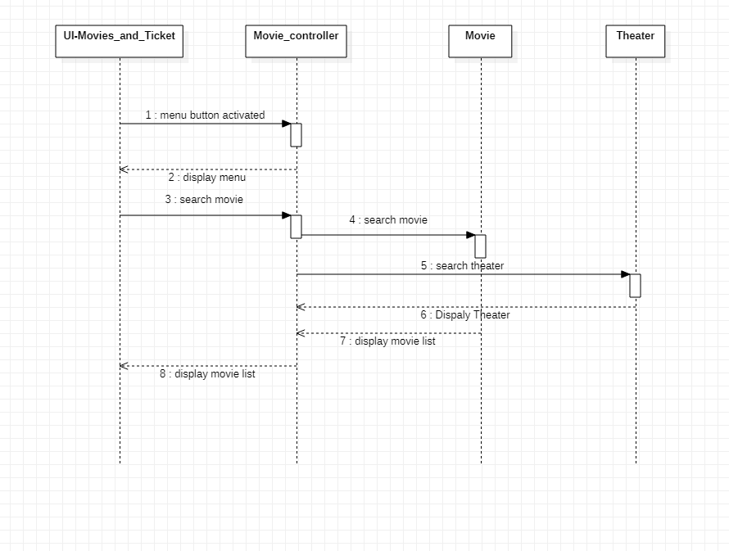

## Buy a Movie Ticket (Amir)

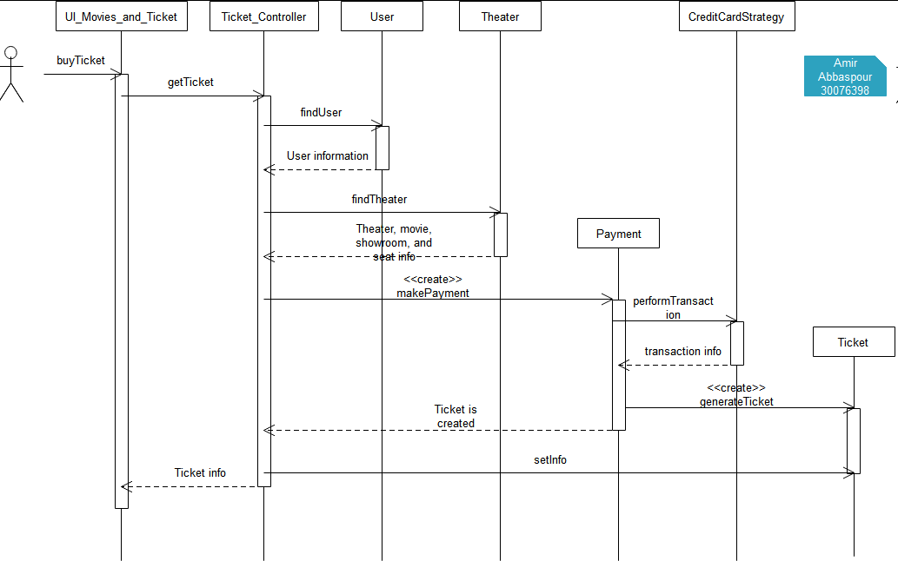

## Refunding a Movie Ticket (Brandon)

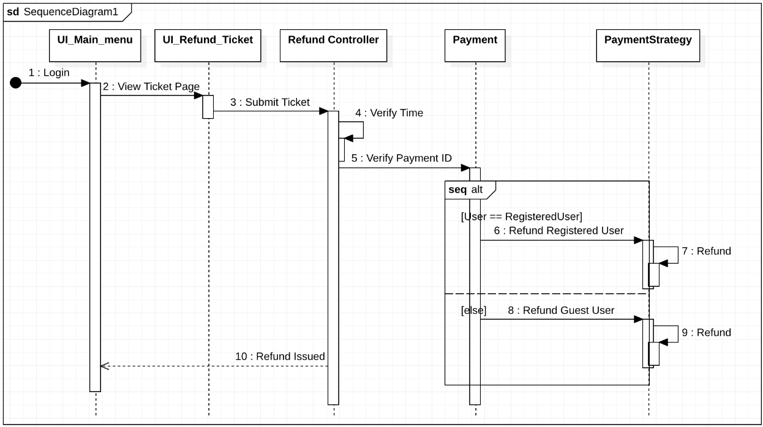

# DESIGN LEVEL CLASS SPECIFICATION (Amir)

## Relationships (group)

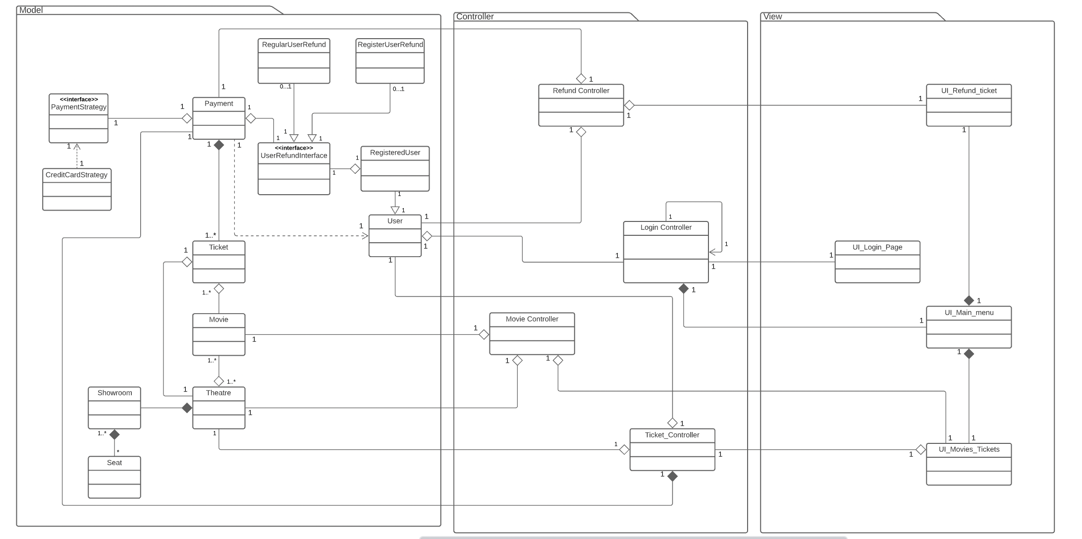

## Attributes & Methods (Amir)

# Package Diagram (Amir)

# Deployment Diagram (Brandon)

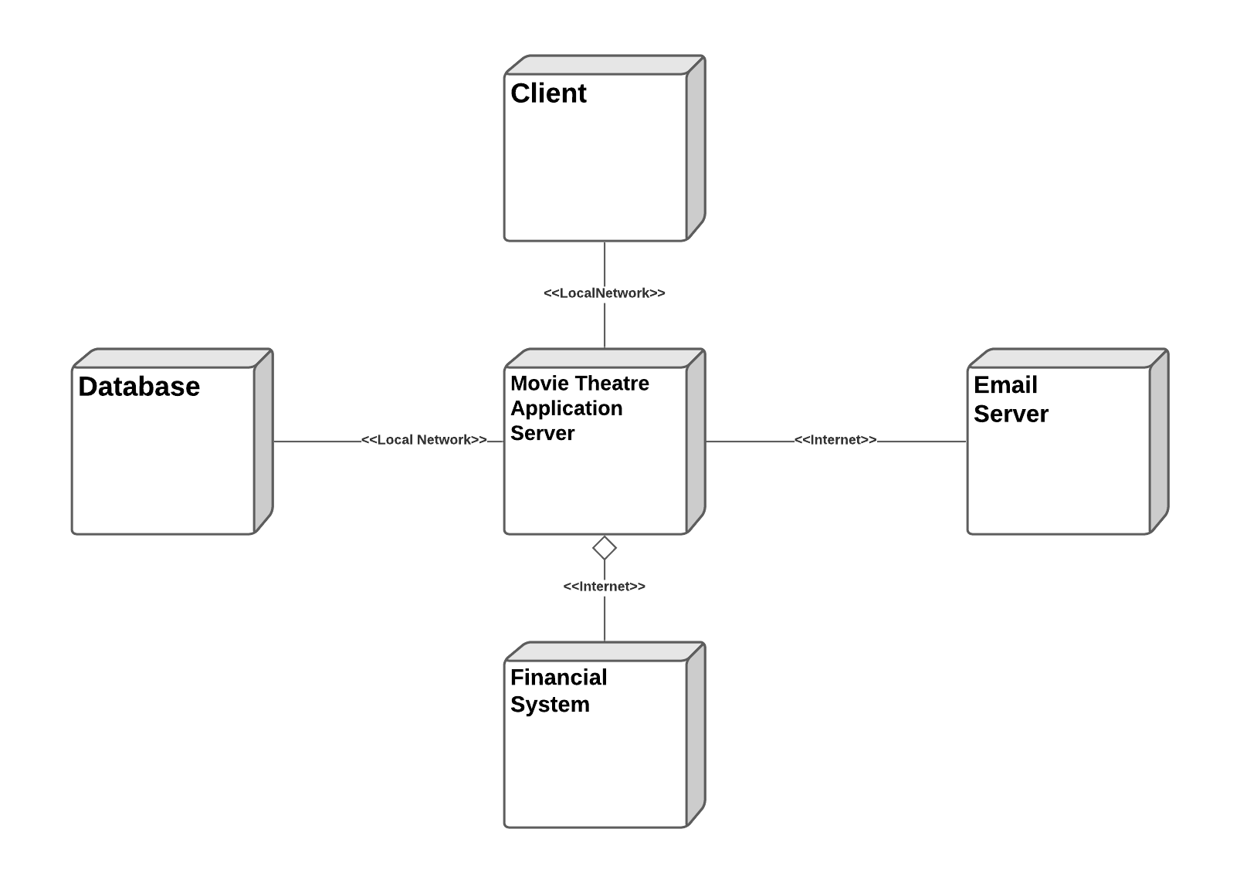

# Appendix A: Wireframes and UI Examples (Michael)

## Login/Continue as Guest

## News (Window that pops up whenever you login) – Receive news.

## Main menu

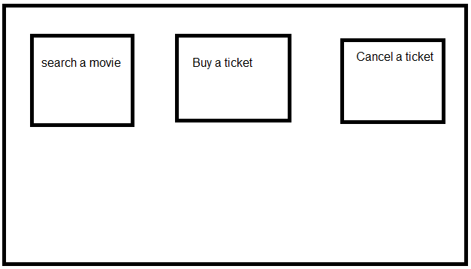

## Movie Search, Theater and Seat Selection & Buy ticket

## Ticket Info (When you press pay, and payment is confirmed by External actor)

## Refund (Enter details and press refund)

